BRISBANE JUNIOR RUGBY UNION (BJRU)
2020 REPRESENTATIVE PROGRAM

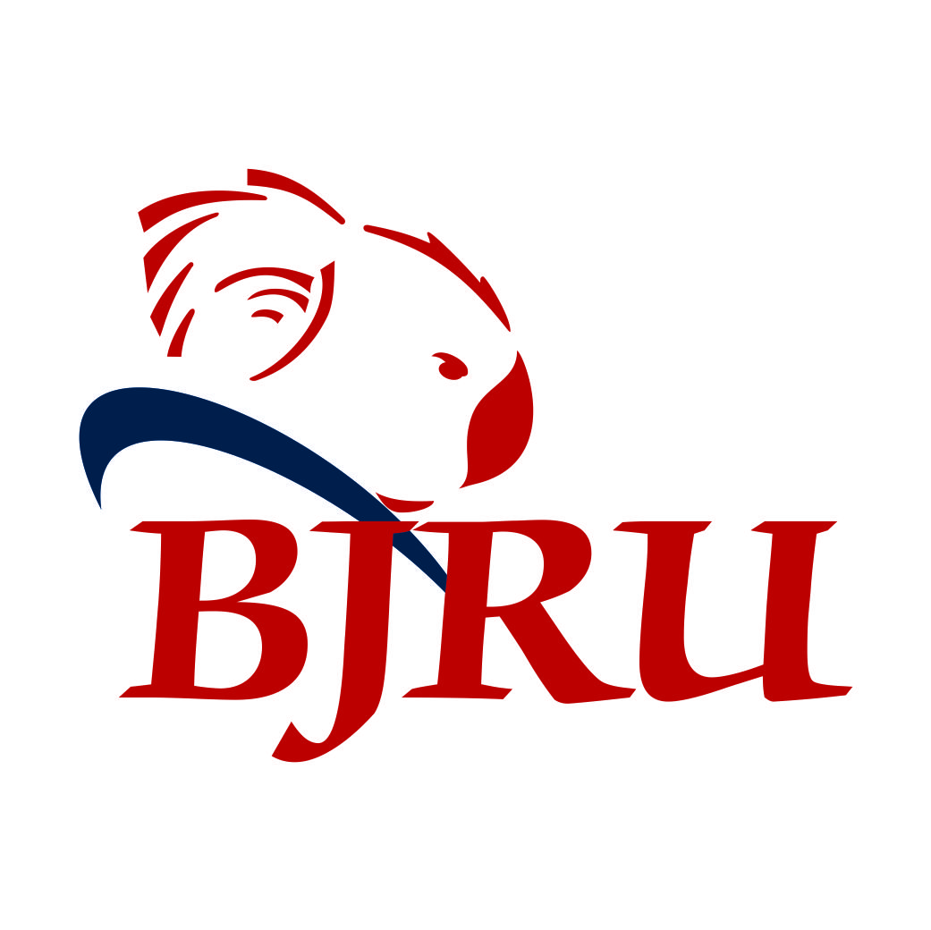

HANDBOOK FOR PLAYERS, COACHES, MANAGERS AND SELECTORS

As at 6 Dec 2019
CONTENTS

1. Scope of Handbook 1

2. Selection of Coaches, Managers and Selectors 2

3. Qualifications and Eligibility 3

4. Organisation 4

5. Accountabilities 5 - 6

6. Specific Duties 7 - 9

7. Selection Process 9 - 11

8. Disputes and Concerns 12

9. Travel Arrangements 13

10. Discipline 14

11. Gear and Dress Code 15

12. Letter of Understanding and Commitment 16

13. Responsibilities and Expectations of Players Selected in BJRU Representative Teams 17

14. Match Day Arrangements 18

15. Player Contact Details 19

16. Parent Contact Details 20

17. Wet Weather Protocol 21

SCOPE

This Handbook deals with the selection, retention and operation of Brisbane Junior Rugby Union (BJRU) Representative Teams only.

Specifically, it addresses the following:

 Selection of coaches, managers, selectors and support staff

 Organisation of the Team for training sessions and matches

 General Team Management issues

This Handbook must be read in conjunction with the Rugby Australia Member Protection Policy, Rugby AU / QRU & BJRU Code of Conduct; the Laws of the Game and any relevant tournament documents.
SELECTION OF COACHES, MANAGERS AND SELECTORS

Appointment of Head Coach, Assistant Coaches, Managers and Selectors shall be competitive and based on merit.

Team Management and selectors positions shall be advertised via the BJRU website, Facebook and through the clubs and affiliated websites.

BJRU has a policy of not appointing a Head Coach (where possible) to an Age Group if that coach has a daughter/son eligible for selection.

Applications may be received as a single application or multiples of any combination of positions.

Any interviews for positions of Head Coach will be conducted by a panel made up of the BJRU Vice President - Representatives (BJRU VP Reps) and any other persons as determined by the BJRU Board.

All Head Coach Applicants will be required to provide a program outline including session plans as part of their application.

Selectors’ positions (minimum of 2) shall be advertised. Applicants for Selectors may be required for an interview at the discretion of the BJRU VP Reps. Selectors need to read and understand the selection process as outlined in this Handbook.

In addition, BJRU Board may approach suitable applicants and encourage them to apply for a position as a member of Team Management.

Selection Committee for Each Age Group shall be appointed as follows:
- Chairman (appointed by BJRU Board and responsible for the process)
 Head Coach
 Assistant Coach
 Selectors (normally 2 but any number as determined by the BJRU Executive) appointed from applicants. Should insufficient suitable applications be received, the BJRU Executive may appoint suitably qualified Selectors or may reduce the number of Selectors appointed.

BJRU may appoint or not appoint any person to any position as they see fit. In addition, a set selection process as outlined in this Handbook will be adopted and co-ordinated by the Chairman of Selectors for each Age Group.

QUALIFICATIONS AND ELIGIBILITY

Coaches

- Head Coaches must, as a minimum, have a Level 1 coaching accreditation (Level 2 preferable and/or be willing to obtain a Level 2 coaching accreditation for U14 and above).

- It is a condition of the appointment of any Coach (Head) to a BJRU Representative Team that they do not coach a club team within the same age group (where possible) as this may impair their ability to view all players for selection purposes.

 Assistant Coaches must, as a minimum, have a Level 1 coaching accreditation; and

 All Coaches (Head and Assistant) must be Smart Rugby accredited and have completed the Staff Integrity Level 1 program in the Rugby Learning Centre.

 All Team Management must present their Positive Notice Blue Card Number and Expiry Date or the appropriate exemption.

In exceptional circumstances the BJRU may appoint a Coach who does not have the minimum qualifications OR Eligibility stated above.

Selectors

 Selectors must agree to work within the framework and selection process as outlined in this Handbook.

 Where possible, all Selectors must view teams prior, as well as attend the selection day for their Age Group.

 All Selectors must attend any selection meetings called by the Chairman of Selectors and / or BJRU VP Reps.

 Selectors appointed cannot hold a coaching position in the same Age Group in which they are to select for BJRU. Any coaching position must not prevent them from having the time and ability to watch players in the Age Group for which they have been appointed.

Managers

All Managers must have completed the Rugby Link Team Manager program in the Rugby Learning Centre.

- All Managers must have completed the Staff Integrity Level 1 program in the Rugby Learning Centre.

 All Team Management must present their Positive Notice Blue Card Number and Expiry Date or the appropriate exemption; or have applied for a Working with Children Blue Card before commencing duties.

- All Managers must attend any Managers meeting called by the Chairman of Selectors and / or BJRU VP Reps.

ORGANISATION

All representative Teams are expressly representing the Brisbane Junior Rugby Union and the chain of authority and accountability is set out below:

Age Coordinators

ACCOUNTABILITIES

Head Coach

To develop teamwork, commitment and the skills of each player so that all players and the team play to their full potential.

To provide a preparation conducive to winning while also ensuring matches are played in a competitive and fair manner.

To maintain a reasonable balance of match time and bench time for all players without compromising the Team’s results.

If there is to be a Queensland side selected in the Age Group then the Head Coach shall be held accountable to ensure that the maximum numbers of players are selected in the Queensland side.

Assistant Coach

Forwards
To develop teamwork, commitment and the skills of the forwards squad particularly in scrum, lineout and tackle / ruck / maul situations and to develop patterns of play as required by the Head Coach.

Backs
To develop teamwork, commitment and the skills of the backs squad particularly in attacking and defensive situations and to develop patterns of play as required by the Head Coach.

Specialist (where applicable)
To develop the specialist skills of players – for example, scrums, kicks etc.

Manager

To provide all services and administration required by the Team, their connections and the BJRU that are not coaching related. This includes the need to submit a formal report at the end of the season. The Manager is expected to liaise closely with both the Head Coach and the BJRU VP Reps.

Selectors

The Chairman of Selectors will ensure that the selection process is carried out in accordance with BJRU policy and is responsible to the BJRU for the selection of each Team.

This will include:

 Consultation of all Selectors with the Head Coach to identify the pattern of play and philosophy required by the Head Coach.

 With the assistance of the Head Coach, selecting a Team that will provide the deliverables to suit that pattern of play and to achieve the objective of winning every match in a competitive and fair manner.

Selectors are appointed by and accountable to BJRU to represent the interests of BJRU in selecting the best players to suit the pattern of play as determined by the Head Coach.

ACCOUNTABILITIES (continued)

Selectors do not represent their clubs and must at all times be objective in determining selections.

BJRU reserves the right to remove any selector who displays overt bias towards any club at the expense of others.

The BJRU President and BJRU VP Reps shall be ex officio members of all selection panels.

Selectors shall have the responsibility throughout the season to observe specific club teams during their respective games to identify appropriate playing talent for the BJRU Team.

This means that they may well have to liaise with the Head Coach of these club teams to seek their co-operation where required.

All work between club and BJRU teams must be co-operative and in the interests of all parties.

SPECIFIC DUTIES

Head Coach

 To plan and execute the representative program as determined by the BJRU Board.

 To provide at the first Selection Meeting, a documented summary of the playing style and player requirements for the game style determined by the Head Coach. This is to be used by the Selection Committee to assist them and provide guidance as to the Head Coach’s requirements.

 To plan and execute training sessions to meet Team objectives. (This may include the identification of suitable training venues.)

 To determine the need for trial matches and to liaise with BJRU VP Reps and / or BJRU Competition Manager for organisation.

 To instruct the Assistant Coach and Specialist Coaches as required.

 To liaise with the BJRU Coach Education Group, QRU Coaching Director, QAS and Pathway Advisory Staff as required.

 To coordinate player injuries / rehabilitation and manage any forced changes to the squad due to injury in conjunction with the Age Coordinator and BJRU VP Rep.

 To attend any pre-tournament camp and tournament functions as required.

 To provide appropriate feedback to the BJRU VP Reps at the completion of the representative rugby season.

Assistant Coach

 To provide services and support as required to the Head Coach.

 To attend any pre-tournament camp and tournament functions as required.

Manager

 To provide direct liaison with the rugby community, BJRU Age Coordinator / BJRU VP Reps and the Team. In addition, it is vital that parents of selected players are well informed of specific details etc for that Team.

 To arrange trials in consultation with BJRU VP Reps as requested by the Head Coach.

 To maintain player / shadow player Contact Details, Participation Forms, Travel Forms etc

 To provide all communications necessary for effective and efficient management of the Team.

 To inform the Age Coordinator and BJRU VP Reps of any “pending issues” in a timely fashion.

 To coordinate the distribution of gear.

 To communicate and manage travel details where required.
SPECIFIC DUTIES (continued)

 To assist players with injuries as required and coordinate rehabilitation.

 To assist in the keeping of statistics as required by the Head Coach.

 To establish and maintain off field Team discipline and behaviour.

 To assist with the coordination of Team photos appropriately.

 To perform any other non-coaching duties as necessary.

 To obtain Team Lists / Player Contact Details from relevant Club Team Managers or BJRU Competition Manager before the Team is finalised.

 To provide the Age Coordinator / BJRU VP Reps with a copy of the Player Contact details once the Team has been selected.

 To provide appropriate feedback to the BJRU VP Reps at the completion of the representative rugby season.

 To arrange distribution of “Letters of Understanding and Commitment” to all parents / guardians and players for their signing and return to the Team Manager.

 To ensure that the Team conducts itself at all times in a professional and appropriate manner while representing the BJRU.

Selectors for each Age Group

In respect of the Age Group the selector is selecting for: -

 Attend all selection trials and as many prior competition games as possible.

 Attend all selection activities as required by the Chairman of Selectors.

 Attend all selection meetings as required.

 Maintain records used to record and measure player performance during the selection process.

SELECTION PROCESS

Selectors will have available a template to be used to aid you in the selection process. It is imperative that the selection process be fair and transparent. Position specific KPIs will aid in the identification of talented players and this process is one used for selection purposes by senior Australian Unions (document of position specific KPI’s added at end).

Pre- Selection process

 The Chairman of Selectors is to provide each selector with a copy of the Head Coach’s written summary of game style and player requirements.

 The Chairman of Selectors is to facilitate a meeting of the selectors for decisions and selections to be made.

Before and During State Championships and Regional Championships

 BJRU VP Reps to arrange briefing meeting with Coaches, Managers and Selectors to outline the BJRU Representative Program and resolve any issues.

 Before each Championship starts the Head Coach and Selectors may, if possible, hold a brief meeting with all the team coaches club teams.

 The Head Coach, Assistant Coach and Selectors should make themselves known to the club coaches before each match.

Team Selection Process and Announcement

 The Selection Committee comprises the Chairman of Selectors, the Coach, one Assistant Coach plus the selectors appointed by BJRU.

 The Chairman of Selectors is to facilitate a meeting of the selectors for decisions and selections to be made.

 The Chairman of Selectors in consultation with the Coach will determine the most appropriate manner in which to handle the selections. That is, do specific selectors look at specific positions (eg inside backs) or do they attempt to select every position.

 Each selector has a maximum of one vote and the player with the majority of votes will be selected.

 It is important that selectors work with the Head Coach to select appropriate players within the framework provided by the Head Coach, but no Head Coach can over-rule the selection panel without the necessary numbers.

 In the event of any selection dispute, it is the Chairman of Selectors responsibility to attempt to resolve any issues. Failing this, any unresolved issues must be referred to the BJRU VP Reps.

 In the U15 Girls 7s a playing squad of 24 members and in the U17 Girls 7s team a playing squad of 24 members will be chosen for the SEQ Rounds; with a final 12 players n each age group taken to the State Championships.

THE SELECTION PROCESS (continued)

Team Selection Process and Announcement (continued)

 The selection of each XVs Team must comply with Law 3, Clause 3.5 Under 19 Variations of the “Laws of the Game”. This means there must be 6 players who can play in the front row and 3 players who can play in the lock position.

 The Team will be selected after the last match used for selection purposes. The Head Coach is to review the selected Team with the BJRU VP Reps, prior to finalising the Team, to determine any concerns or issues. All selections must remain strictly confidential at all times.

 Notice of the selected Team will be emailed by the Chairman of Selectors to the BJRU Competition Manager who will arrange for publication the following day.

 The notice will detail:
o The ID number and full name of the persons selected
- Their Club and Team name and playing position/s
o the time, date and place of the first training session
o Details of any further training sessions
o the contact details of the Manager
o A statement that makes it clear what to do if unable to attend the first training session

 Selected players should be contacted personally by a member of the Team Management and advised of their selection as soon as possible after selection is finalised and ideally prior to publication of the Team.

 Each player selected and his Parents / Guardians shall complete a Letter of Understanding and Commitment confirming the player’s selection in the Team, the team program and the expectations of BJRU and Team Management regarding the Code of Conduct, commitment to the Team, attendance and conduct at all training sessions and matches. The Letter of Understanding and Commitment will also outline possible consequences for a player who fails to meet the expectations of the BJRU Committee and Team Management.

Shadow Players

 A further 7 to 12 “Shadow Players” will be selected but not announced to cover replacement of injured players for a particular match or matches. A copy of this list is to be provided to the BJRU VP Reps for the record.

 Shadow Players may only be used to replace injured players or players expelled from the Team.

 Shadow Players will not be issued with gear unless they are actually called into the Team.

 No Shadow Player may be brought into the squad without prior consultation with and written ratification by the BJRU VP Reps and BJRU President.

THE SELECTION PROCESS (continued)

The First Training Session

 By the conclusion of the first training session a decision must be made by Team Management regarding the future of those absent. Any decision to expel a player from the Team must first be discussed with and ratified in writing by the BJRU VP Reps and BJRU President.

 All absent players must be phoned by the next day following the training session concerning the reason for their absence.

 Any replacement players must be notified by the next day after the person to be dropped has been notified after that has been ratified in writing by the BJRU VP Reps and BJRU President.

 Each player is to be provided an information pack with contact details and an outline of the program and whatever other information is needed that makes the management of the Team easier and the expectations of the Team members understood. This includes:
o Coaches, Managers and Sports Medics contact details
o Calendar of Events
o Any Camp or travel details.
o Dress Code
o What to bring

Selection Changes

 All players in the selected Team will play in all trials and will be included in the squad for the first competitive match unless injured.

 Players may be dropped for subsequent matches and trials (for disciplinary or injury reasons only) and replaced by Shadow players. Any decision to replace a player from the Team with a Shadow Player must first be discussed with and ratified in writing by the BJRU VP Reps and BJRU President.

DISPUTES AND CONCERNS

Should any issues arise at any time during the season or any concerns over the conduct of the Team, then these matters must be reported firstly to the Chairman of Selectors – Age Coordinator or the BJRU VP Reps. This includes both on field and off field matters.

It must be clear that any matter of concern or dispute must at all times be referred to the Chairman of Selectors – Age Coordinator and the BJRU VP Reps for appropriate determination of actions necessary.

BJRU will then determine the most appropriate way in which this matter should be handled and resolved. Matters of internal dispute that cannot be handled by the Team Management must at all times be referred to the Chairman of Selectors – Age Coordinator or the BJRU VP Reps or the BJRU VP Reps for determination.

TRAVEL ARRANGEMENTS

Travel Outside Brisbane

 Travel to the venue by bus as arranged by BJRU, is compulsory (unless otherwise approved). The Team should arrive at the venue 90 minutes before their match starts.

 Dress as prescribed must be worn.

 Food such as sandwiches and fruit may be provided during the bus trip. Players may be advised to bring this along or by prior notification, the cost of this may be reimbursed by BJRU (Only upon provision of receipts).

 At least two members of the Team Management is to travel on the forward bus journey.

 Any Buses will leave from one central point.

 Return travel may be by bus or private car as arranged with Team Management. At least one member of Team Management is to travel on the return bus journey.

 Appropriate Waivers / Permissions to be signed by all Parents / Guardians.

Within the Brisbane Region

 In Brisbane, teams will assemble at the venue 90 minutes before the match is scheduled to commence.

 Team Management are required to arrive at the venue 90 minutes before the match starts or earlier if required.

DISCIPLINE

 Team Management is responsible for Team Discipline at training sessions, game day and travel. This also applies in particular to any specific camps that have been arranged. For example, the Girls XVs Training Camp.

 Minor problems should be dealt with “in house” as far as possible and ideally with the support of the Team Leadership group.

 More serious offences need to be dealt with firmly but fairly and in a timely manner. It is essential that Team Management present a united front in dealing with such issues. A meeting of Team Management should decide on an appropriate course of action and all support this position. If agreement is not reached then the Manager has the final say on disciplinary matters. Some typical measures for serious discipline breaches include restitution of monies and apology, banning from social activities for a period of time, suspension from playing for a period of time, informing player’s parents and in severe cases expulsion from the Team.

 The Chairman of Selectors and the BJRU VP Reps must be advised of all serious offences. Any decision to expel a player from the Team must first be discussed with and ratified in writing by the BJRU VP Reps and BJRU President.

 Appropriate Team bonding is highly regarded and is an expectation of the BJRU Board. Teams are expected to operate as “Teams” both during matches and off field when representing BJRU.

GEAR / DRESS CODE

The following items of gear may be distributed to players and Team Management:

 Players:
o Playing Jersey
o Playing shorts
o Playing socks
o Training shirt
o Polo Shirt
o Hoodie / Tracksuit
- Bag
- Cap

 Team Management:
o BJRU Polo
o Jacket
o Hoodie / Tracksuit
- Pants / Shorts

Dress Code-Travel and Game Day / Tournament:

- During travel to and from:
  - Local or regional venue players are to be dressed in training shirts, shorts/tracksuit and/or hoodie and joggers. Open toed shoes or thongs are not permitted.
  - an interstate or overseas venue players are to be dressed in long pants, closed shoes, Team polo and hoodies. Open toed shoes or thongs are not permitted.
2. For the Girls XVs side, players will travel in the attire outlined above. On game day players will dress in tracksuit and Team polo.
3. Any training sessions and warm ups will be conducted in players training shirts.

LETTER OF UNDERSTANDING AND COMMITMENT

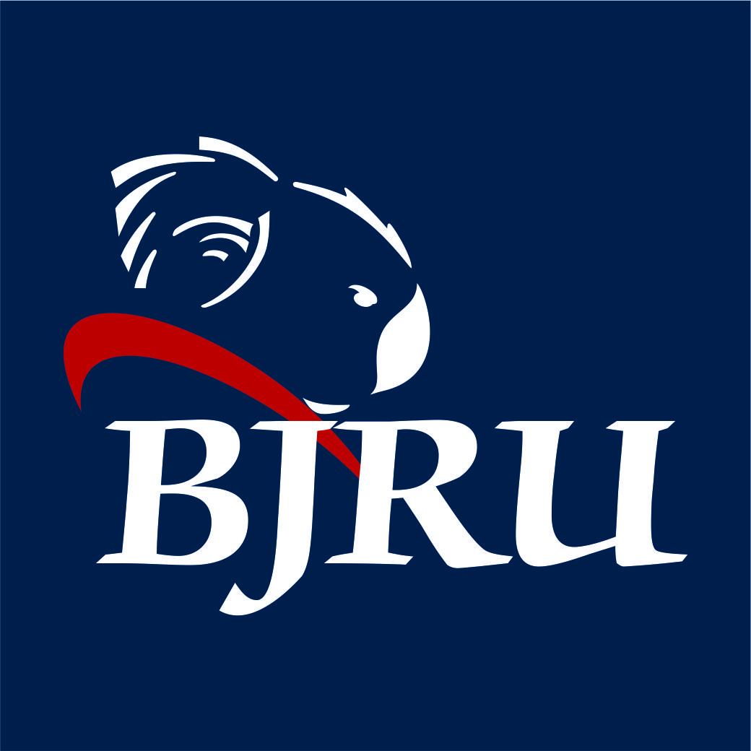

To Parents / Guardians:
As a Parent / Guardian of a player representing Brisbane Junior Rugby Union (BJRU), I agree to abide by the following:
(1) I will ensure that my daughter/son complies with the guidelines outlined in the Responsibilities and Expectations of Players Selected in BJRU Representative Teams.
(2) I will abide by rules and requirements set by Team Management and the BJRU.
(3) I will be responsible for any wilful damage of property by my daughter/son.
(4) I have advised the Team Manager of any medical conditions of my daughter/son (eg asthma etc) which may impact on his training regime or during matches.
(5) I have advised the Team Manager of the Player Contact Details and the Parent Contact details.

To Players:
As a player representing Brisbane Junior Rugby Union (BJRU), I agree to abide by the following:

(1) I will comply with the guidelines outlined in the Responsibilities and Expectations of Players Selected in BJRU Representative Teams.
(2) I will abide by rules and requirements set by Team Management and the BJRU.
(3) I will respect other players and their property.
(4) At all times I will strive to give my best effort for the Team and attend all training sessions, trial matches etc as required.
(5) I am aware of the Rugby Australia Code of Conduct and BJRU Code of Conduct and agree to uphold it at all times.

NAME OF PLAYER: _______________________________________

AGE GROUP _______________________________________

TEAM _______________________________________

SIGNATURE (Player) _______________________________________

SIGNATURE (Parent/Guardian _______________________________________

Date _______________________________________

RESPONSIBILITIES AND EXPECTATIONS OF PLAYERS SELECTED IN BJRU REPRESENTATIVE TEAMS

Congratulations on your selection to represent Brisbane Junior Rugby Union (BJRU). This is an honour afforded to only a few players and with that honour comes certain responsibilities and expectations.

It is important that you understand that you are representing BJRU and that these expectations will apply to you at all times whilst you are representing BJRU.

These responsibilities and expectations include:

(1) It is expected that you will commit yourself fully to the Team and that you will not accept selection in any other Team that will compete with the BJRU Team that you were selected for in the current season.
(2) It is an expectation that you will at all times apply yourself 100% at all training sessions and matches organised for the Team in which you are selected.
(3) It is expected that you will attend all training sessions and bonding sessions arranged for the Team. Failure to attend will be treated seriously.
(4) It is expected that you will make yourself available for any travel commitments required while representing the BJRU Team where travel may be involved.
(5) If you are unable to attend a training session for any reason, it is vital that you inform the Team Management prior to the commencement of the training session. If this is not possible, you must make contact with Team Management as soon as possible after the training session outlining your reasons for your absence.
(6) It is expected that you will understand the role of a “Team” and that you will at all times act in the best interests of the Team.
(7) It is expected that you will treat all fellow players, Team Management and Officials with an appropriate level of respect at all times when representing the BJRU.
(8) It is expected that you will at all times comply with the Rugby Australia Code of Conduct and the BJRU Code of Conduct.
(9) Normal standards of behaviour are expected of the players and they are expected to respect the rights of others as regards personal property etc.
(10) Parents will be informed of any serious behavioural problems of a player.
(11) The BJRU reserves the right to impose a penalty for any serious breach of conditions, including expulsion from the BJRU Representative Team.

MATCH DAY ARRANGEMENTS

MATCH DAY CHECKLIST
Match
Date
Venue
PRE MATCH
Have full Team list prepared
Meet at assembly point
Allocation of change room
Prepare a valuables bag for phones etc
Pre match strapping
Warm up equipment prepared
Ensure water bottles filled and ice available
Allocate jerseys
Have knowledge of location of First Aid personnel
Ensure kicking tee available with nominated runner
DURING MATCH
Record result, scorers and RC and YC offences during the match
Ensure reserves are in correct jerseys
Note any medical concerns during and after the match
POST MATCH
Collect jerseys at end of the match
Ensure all gear / equipment collected
Communicate medical issues to Head Coach
Ensure change room left neat and tidy
MANAGERS KIT SHOULD CONTAIN
Spare studs
Electrical tape
Garbage bags
Spare kicking tee
Spare jerseys, shorts and socks, mouthguards
Phone Charger and cable
Coin for toss
Pens
Players Contact List

Player Contact Details
Team:
No. | Surname | First Name | District | Position | DOB | Mobile | Home Phone | E-mail address | Address
1
2
3
4
5
6
7
8
9
10
11
12
13
14
15
16
17
18
19
20
21
22
23

Parent Contact Details
Team:
Player |  |  | Father |  |  | Mother
No. | Surname | First Name | First Name | Mobile | E-mail address | First Name | Mobile | E-mail address
1
2
3
4
5
6
7
8
9
10
11
12
13
14
15
16
17
18
19
20
21
22
23

Wet Weather Protocol

Coaches will make a decision re weather cancellations at least 2 hours prior to training. All attempts will be made to notify players and parents at the earliest possible time. This can be done through the BJRU Facebook page.

Cancellations will be advised ASAP by text and email BUT, if in doubt contact team manager.

REPRESENTATIVE TEAM LIST
AGE |  |  | COLOUR
Rugby Link ID | Players Name  (LAST Name, First Name) | Primary Position |  | DETAILS
 |  |  |  | CLUB | TEAM COLOUR | Other Position
 |  | 1
 |  | 2
 |  | 3
 |  | 4
 |  | 5
 |  | 6
 |  | 7
 |  | 8
 |  | 9
 |  | 10
 |  | 11
 |  | 12
 |  | 13
 |  | 14
 |  | 15
 |  | 16
 |  | 17
 |  | 18
 |  | 19
 |  | 20
 |  | 21
 |  | 22
 |  | 23

HEAD COACH
ASST COACH
SELECTOR
SELECTOR
AGE CO-ORD
FINAL APPROVAL
 | Name |  | Date | Signature
REPRESENTATIVE SHADOW LIST
AGE |  |  | COLOUR
Rugby Link ID | Players Name  (LAST Name, First Name) | Primary Position |  | DETAILS
 |  |  |  | CLUB | TEAM COLOUR | Other Position

HEAD COACH
ASST COACH
SELECTOR
SELECTOR
AGE CO-ORD
FINAL APPROVAL
 | Name |  | Date | Signature

VENUE: _______________ TEAM: _______________ AGE:_________ DATE: / /2020 SELECTOR: ____________

NAME | JERSEY  NO | Pos. | ROLE SPECIFIC | SKILLS (out of 5) /5 |  |  |  | PHYSICALITY (OUT OF 5) /5 |  |  |  | COMMENTS
 |  |  |  | Tackle | Catch | Pass | Kick | Stren-gth | Body Post’n | Speed | Fitness

Key:

Skills - Tackle-technique in attack and defence
Catch-under pressure, lineout, catching a kick
Pass- speed, accuracy, clearing pass
Kick- length and height and accuracy of punt /place / drop

Physical- Strength –in contact and set play
Body Position- in tackle, running, set play and phase play
Speed- hand and foot speed, changing direction, acceleration
Fitness- match endurance

NB: Role Specific column will depend on your coaching/selecting philosophy. List the most desirable qualities you need to see.

Coach |  | Age Group
Aim of Program
Coaching Style
Proposed Game Style
PROGRAM OUTLINE
Session No | Key Factors | Drills Involved | Success Indicators

